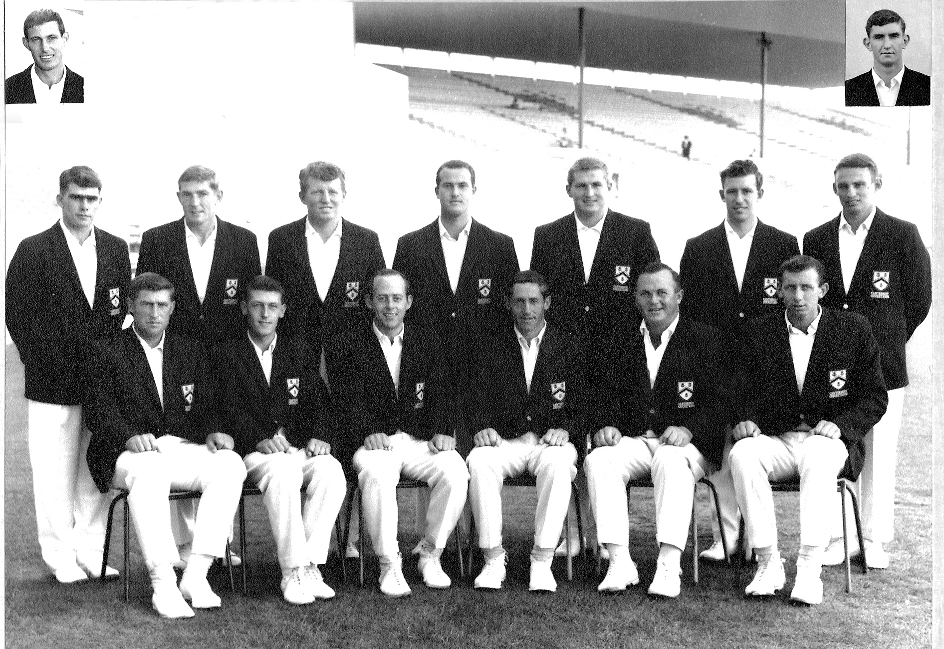

**Canterbury Representative Team 1966/67 First NZ team to defeat an Australia XI**

**Back row:** BP Isherwood, KI Ferries, CJ Stevens, JM McIntyre, ML Ryan, WJ Burtt, CL Bull

**Front row:** RC Motz, JT Ward, BF Hastings, GT Dowling, K Thomson, BR Taylor

**Inset:** CL Broad, B Andrews